Project Scenario

Step 1: Create your own project scenario and data

You are a software developer hired by a local video-game store, Prime Games Singapore, to manage the sales of the latest next generation game consoles. Currently, interested customers phone the store to enquire the details and prices of the different types of game consoles before making their purchase. They are also interested to know the different bundle deals and various warranty packages. Due to high demand, customers must wait for a long time before they are answered by the sales assistants, who are overwhelmed by the customer enquiries.

Prime Games Singapore would like you to develop an easy-to-use one window* application to ease the situation and ensure customers get the opportunity to purchase the latest next generation consoles. The program should have the following key features:

- A featured product section to display the top-3 selling game consoles and allow customers to buy them by clicking any of the 3 game consoles.

- A product list section to display all the 6 game consoles. At any one time, customers can click on one of the products to view product details, image, and price.

- An add-on section to display the upgrade bundle deals available to each console. The options available are the console bundled with a gaming headset (Teamspeak Bundle), a bundle deal with 2 of the latest games included with the game console (Value Bundle), and a bundle deal with a media remote and 6 months Premium Netflix subscription included (Entertainment Bundle). Customers can choose to purchase all the upgrade bundles. There are 3 options available in total.

- A section to display warranty packages: Basic, Prime, and Invincible. The Basic warranty package includes 1 year of warranty. The Prime warranty package will include 2 years of warranty. The Invincible warranty package will include 3 years of warranty with servicing at the customer’s doorstep.

- Customers should be able to specify the quantity of game consoles they are purchasing.

- A discount of 3% will be given to customers if their total purchase exceeds $750. A discount of 5% will be given to customers if their total purchase exceeds $1000. A maximum discount of 7% will be given to customers if their total purchase exceeds $1300.

- A promotion code section for customers to enter a promotion code to get free peripherals and goodies during the promotion period. The promotion code “AdventurerSG” is awarded to the first 15 buyers that purchase their game console using the software. The promotion code “FunForAll” is awarded to the first 50 buyers that purchase their console using the software. The promotion code “GamerSG” is awarded to the first 75 buyers that purchase their console using the software. An image of the product will be shown when the promotion code is entered successfully.

- When the Buy button is clicked, a purchase summary will be calculated and displayed.

*One Window: Means everything is displayed in one single window.
**To make it simple, in this project, you can assume:
  - At any one time, customers can only buy multiple quantity of one type of game console
  - The quantity of the promotion bundles as well as the warranty package is equal to the quantity of the game consoles purchased.
  - Each customer is only entitled to a single promotion item from entering a promotion code.

Based on your project scenario, determine the details, image, and price of the products you are going to sell.

6 products or services

S/No | Product Name | Product Image | Unit Price | Detail Specification
1 | PlayStation 5 | 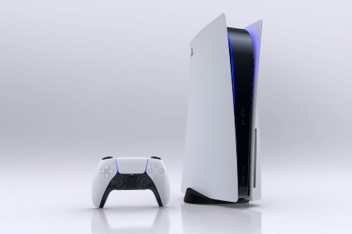 | $729 | Play Has No Limits: Marvel at the incredible 4K graphics and experience the new PS5 features.
2 | PlayStation 5 Digital Edition | 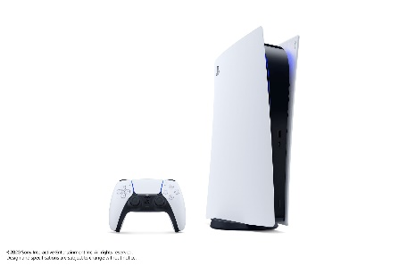 | $599 | Play Has No Limits:  The PS5 Digital Edition is an all-digital version of the PS5 console, with the same amount of speed as the PS5.
3 | Xbox Series X | 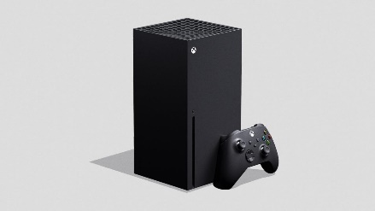 | $699 | The Fastest, Most Powerful Xbox Ever: Embark on new adventures the way they’re meant to be experienced with 4K gaming on the Xbox Series X.
4 | Xbox Series S | 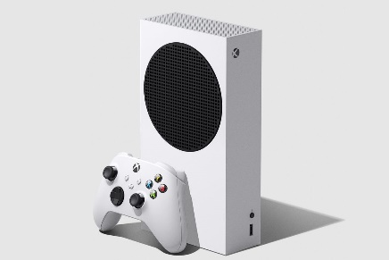 | $459 | The Smallest Xbox Ever: The all-digital Xbox Series S is the best value in performance gaming.
5 | Nintendo Switch 3rd Generation | 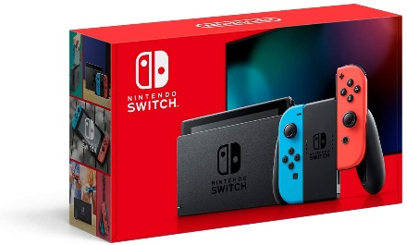 | $499 | Three Modes in One: The upgraded Nintendo Switch with 4K-TV support is designed to fit your life, transforming from home console to portable system in a snap.
6 | Nintendo Switch Lite 2nd Generation | 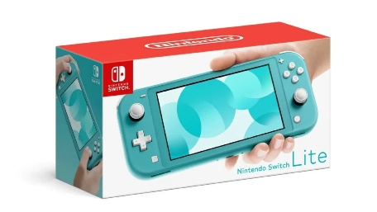 | $329 | Dedicated To Handheld Play: The upgraded Nintendo Switch Lite with extended battery life is designed specifically for handheld play.

Top 3 products or services

S/No | Product Name | Product Image | Unit Price | Detail Specification
1 | PlayStation 5 |  | $729 | Play Has No Limits: Marvel at the incredible 4K graphics and experience the new PS5 features.
2 | Nintendo Switch 3rd Generation |  | $499 | Three Modes in One: The upgraded Nintendo Switch with 4K-TV support is designed to fit your life, transforming from home console to portable system in a snap.
3 | Xbox Series X | 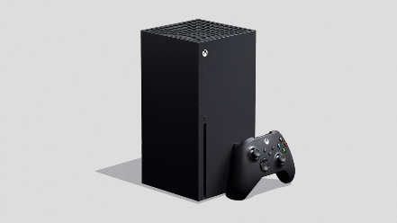 | $699 | The Fastest, Most Powerful Xbox Ever: Embark on new adventures the way they’re meant to be experienced with 4K gaming on the Xbox Series X.

3 Add-ons

S/No | Product Name | Product Image | Unit Price | Detail Specification
1 | Teamspeak Bundle:  Gaming Headset | 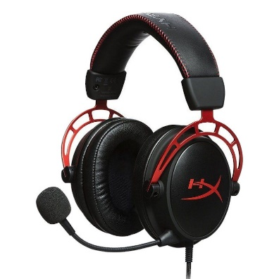 | $109.00 | Prove your skills with the squad when you pick up the HyperX Cloud Alpha Gaming Headset!
2 | Value Bundle:  2 Additional Games | 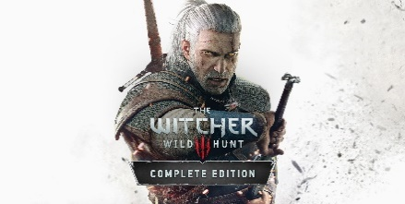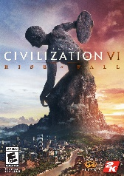 | $130 | Save up to $20 when you purchase the value bundle along with your game console!
3 | Family Bundle:  Media Remote + 6 Months Premium Netflix Subscription | 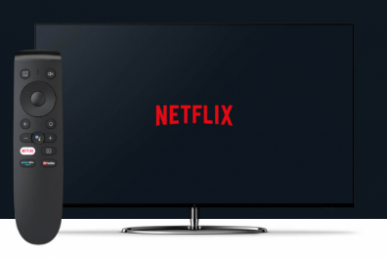 | $139 | Have a great time with your family! The family bundle comes with a premium Netflix subscription and a media remote to go along with your game console!

Warranty Packages

S/No | Package Name | Unit Price | Detail Specification
1 | Basic | $49.99 | A basic 1-year warranty plan included with the purchase of your console.
2 | Prime | $79.99 | A premium 2-year warranty plan to ensure that your console is always in good shape.
3 | Invincible | $129.99 | The best of the best, a 3-year warranty plan that includes servicing at your doorstep.

Discount Schemes (minimal 3 schemes)

S/No | Based on Minimum Total Amount | Discount Given
1 | >= $750 | 3%
2 | >= $1000 | 5%
3 | >= $1300 | 7%

Promotion Codes (minimal 3 codes)

S/No | Promotion Code | Product Image | Product Given
1 | “GamerSG” | 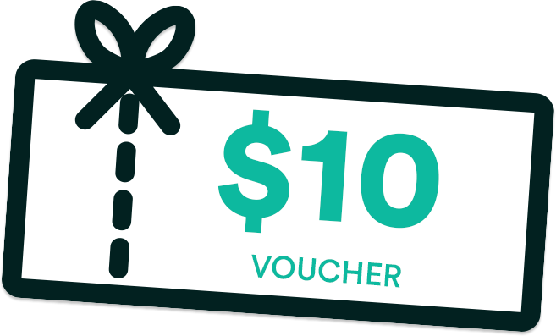 | Free $10 Store Gift Card
2 | “FunForAll” | 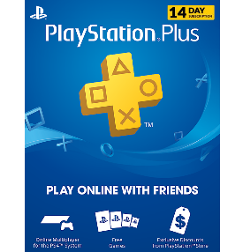 | Free 14 Days Online Multiplayer Subscription
3 | “AdventurerSG” | 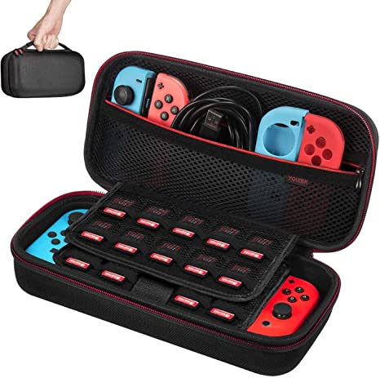 | Free Game Console Case

Step 2: Wireframe
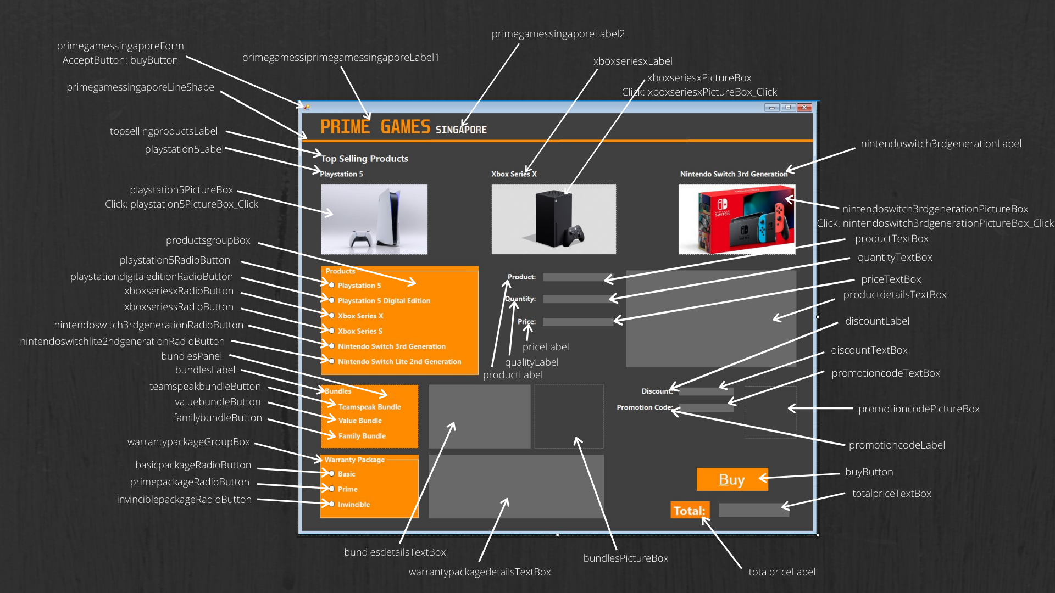

Step 3: Flow Charts

Note: My program features 2 price text boxes. The first price text box is to showcase the price of the product with add-ons and maintenance. This is why the price and quantity of the products are taken into account for calculation for the first 4 flowcharts. It was intentionally designed this way to provide immediate feedback to let customers know the price of a product before discount. The second price text box, that only displays text once the buy button is clicked, is to summarise the total price after discount and promotion codes.

Flow Chart for selection of a product in Featured Product section
Create a flow chart for what the code needs to do when users click a product.

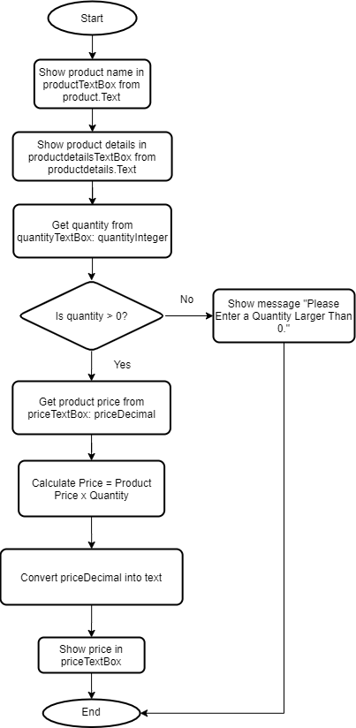
Flow Chart for selection of a product in Product List section
Create a flow chart for what the code needs to do when users click a product.

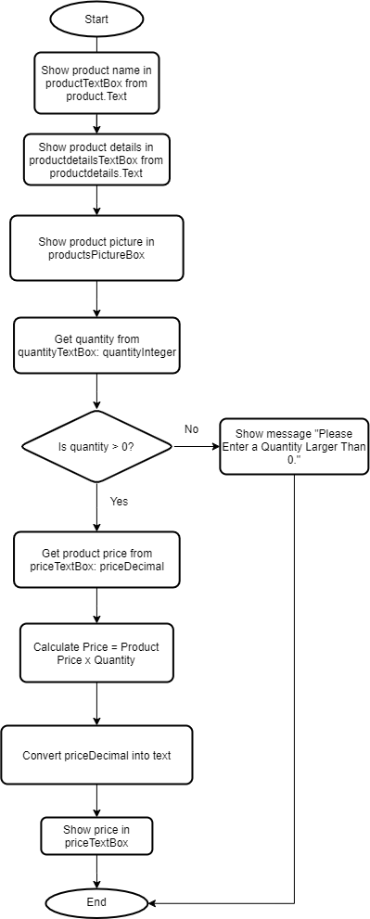

Flow Chart for selecting add-ons in Add-On section
Create a flow chart for what the code needs to do when users select an Add-on.

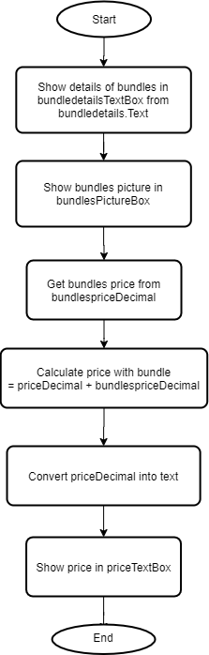

Flow Chart for Maintenance Packages
Create a flow chart for what the code needs to do when users click a package.

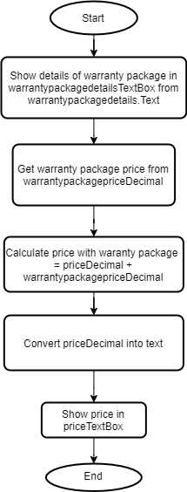

Flow Chart for clicking on Buy button
Create a flow chart for what the code needs to do when users click the buy button.

